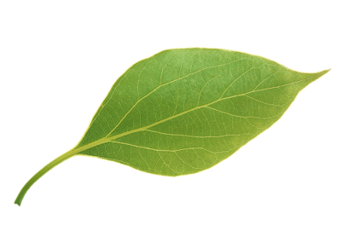

|  |  |  |  |  |
| --- | --- | --- | --- | --- |
| **EXPLORE** | **CREATE** | **CHALLENGE** | **GARDEN** | **HELP** |
| Have a beach day & float in the sea  [Swim Ireland (meandthewater.ie)](https://swimspots.meandthewater.ie/) | Create Nature Art, make jewellry or sketch outdoors | Challenge your friends to the Garden Obstacle Course Olympics | Find 10 new plants with PlantNet App | Local rubbish pick or beach clean up |
| Go for a hike or climb a small mountain | Revamp your bedroom | Go for a run or do Couch to 5K | Host a Yoga Party or play crab-soccer | Walk the dog or teach a new trick |
| Explore a Nature Reserve, a Forest, a new Park and climb a tree | Host an upcycle fashion show, a swap party, or make something new | Try Camping with your friends – even in the back garden | Start a veg zone in your garden or make a chill out zone | Plant flowers in your garden or patio pots for bees |
| Try geocaching with your family or friends | Try Nature Photography | Learn a safe Tik Tok challenge or a new dance move | Read a book | Learn to Recycle & WEEEcycle |
| Visit an Open Farm or attend a Festival | Make a Bird House, a walking stick or candles | Learn a new life skill- like driving, ironing, cooking, read a map, sew a button | Eat Breakfast Outdoors | Have a No Binned Food Day |
| Splash in a Water Park,visit a Theme Park,join a teen camp | Start a Journal or create your own comic strip | Help out an elderly neighbour – bake, gardening, shopping | Go Mothing after Dark or on a bat hunt | Leftovers War- invent new meal |
| Test yourself at an Adventure Centre – Try a new activity that scares you! | Create Friendship Bracelets or make a Stop Motion Movie | Make a Scavenger Hunt around your area for your friends – pick places & objects, then hide clues. | Have a night picnic with friends | Declutter & sell on Depop or upcycle a top |
| Cycle to somewhere new or cycle a Greenway | Try making Slime or a Homemade Rocket | Cook dinner for your family or friends | Ice Cream Party, with ice cream floats | Plan your next family trip |
| Do something unexpected today | Make homemade ice cream | Raise money for charity | Dance in the Rain | Start an Upcycle Project |
| Explore a random town in your county | Make Bath Bombs or Giant Bubbles | Family Outdoor Games Night & BBQ | Bury A Time Capsule until 2026 | FREEcycle unused stuff |

Check out [www.Naturdays.ie](http://www.Naturdays.ie) for more ourdoor activity ideas & let your parent/guardian know your plans too.

**Teen Summer Bucket List**

See how many activities you can

complete outdoors over the summer holidays