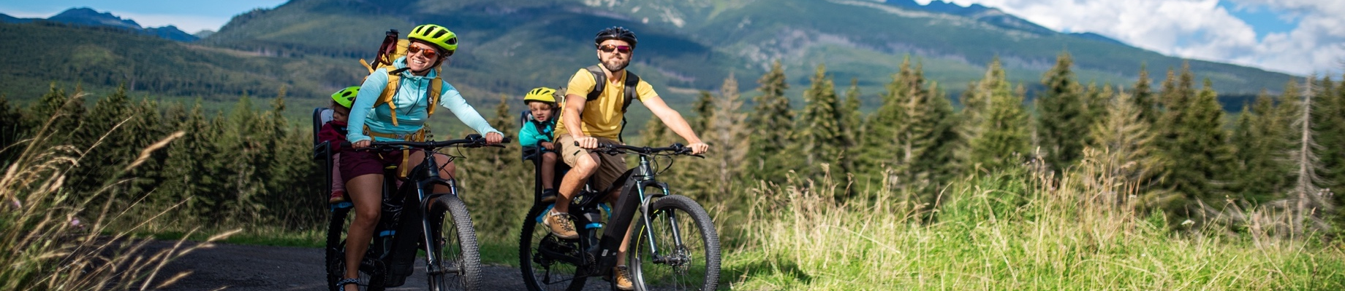


0
Spring Activities Bucket List

NATURE  EXPLORE | NATURE  CREATE | NATURE  PLAY | NATURE  GARDEN | NATURE  HELPERS
Enjoy a Spring snowdrop & bluebell hunt in your area | Make your own bird nest box | Go on a worm hunt after rain | Plant Spring bulbs, like daffodils or tulips, in pots | Have a litter pick party
Find new growth buds with our Bud Spotter | Make a simple Bird Feeder | Wellies on for puddle jumping | Make Seeds bombs | Head off on a beach clean together
Hike Day - pick a route everyone can manage or try Geocaching | Start a Nature Journal | Have a Garden Easter Egg Hunt | Create a Kids Gardening Zone | Plant flowers in your garden or patio pots for bees
Enjoy a country drive to see new rabbitts, lambs and calves | Take Nature Photographs | Make a den in a nearby woodland | Teach kids how to look after plants | Learn to Recycle & WEEEcycle
Visit an Open Farm in your area | Make leaf and bark rubbings outside | Make giant bubbles | Eat Breakfast Outdoors | Have a No Binned Food Day
Go on a family Scavenger Hunt & picnic | Make a mini Bug Hotel in your garden | Explore woodland for great climbing trees | Create a kids digging zone in your garden | Try 3 new meat free recipies
Get moving at an outdoor Adventure Centre | Create a small Fairy Garden outside | Host a Scavenger Hunt party in your garden | Sow edible plant seeds in pot – lettuce, herbs, fruit | Try a No Car Day
Visit a new park and feed the ducks | Paint stones for your garden | Take out your chalk and get creative | Have a Garden Bug Hunt | Plant a Tree or support a charity
Cycle or walk a Greenway | Make Nature Faces on trees with sticky mud | Play I-Spy in the garden | Plant sunflower seeds and see who’s grows tallest | Upcycle something
Visit a wildlife park in your area | Make your own painted walking sticks | Raid the shed and make a garden fort | Garden Bird spotting | FREEcycle something after a clear out
Check out Naturedays | Activity Finder or “Search” in www.naturedays.ie for details on lots of these activities

